Layered Architecture
# Source: AI Source: Provided by: [Data Path: Persons Table -> ID Column: 1, Name_En Column: Motasem Essam] -> From: [ChatGPT] on [1/23/2026]
Layered Architecture (also called n-tier architecture) organizes a software system into layers, each with a specific responsibility. This is one of the most common architectures in enterprise applications.
👉 Think of it like a layered cake—each layer has its role and communicates only with the layer directly above or below.

🔑 Key Points
# Source: AI Source: Provided by: [Data Path: Persons Table -> ID Column: 1, Name_En Column: Motasem Essam] -> From: [ChatGPT] on [1/23/2026]
- Separates concerns into Presentation → Business → Data layers
- Improves maintainability, readability, and reusability
- Each layer can be modified independently if interfaces are consistent

🧱 Structure Example
# Source: AI Source: Provided by: [Data Path: Persons Table -> ID Column: 1, Name_En Column: Motasem Essam] -> From: [ChatGPT] on [1/23/2026]
Presentation Layer → Business Layer → Data Layer
Controller → Service → Repository → Database
- Controller / Presentation Layer → Handles user interface and requests
- Service / Business Layer → Contains business rules and logic
- Repository / Data Layer → Handles data storage and retrieval

❌ Common Problems (Bad Practice)
# Source: AI Source: Provided by: [Data Path: Persons Table -> ID Column: 1, Name_En Column: Motasem Essam] -> From: [ChatGPT] on [1/23/2026]
- Placing unrelated code in the wrong layer: e.g., database logic in the controller
- Overly strict layering can create unnecessary complexity
- Too many layers can cause performance overhead
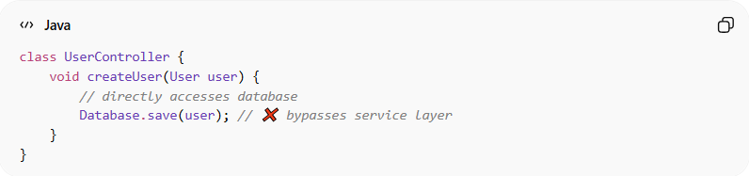
class UserController {
void createUser(User user) {
// directly accesses database
Database.save(user); // ❌ bypasses service layer
}
}

✅ Benefits (Good Practice)
# Source: AI Source: Provided by: [Data Path: Persons Table -> ID Column: 1, Name_En Column: Motasem Essam] -> From: [ChatGPT] on [1/23/2026]
- Clear separation of concerns
- Easier to maintain and extend
- Layers can be reused across multiple parts of the system
- Facilitates unit testing of individual layers
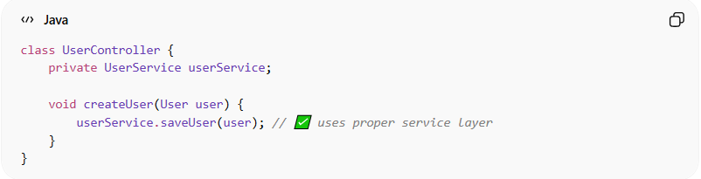
class UserController {
private UserService userService;

void createUser(User user) {
userService.saveUser(user); // ✅ uses proper service layer
}
}

⚡ When to Use
# Source: AI Source: Provided by: [Data Path: Persons Table -> ID Column: 1, Name_En Column: Motasem Essam] -> From: [ChatGPT] on [1/23/2026]
- Enterprise applications with multiple components
- Projects that need modularization and maintainability
- Systems where separation between UI, business logic, and data is important

